Working of Serial Input with an equation and displaying result on interfaced LCD

**Diagram**

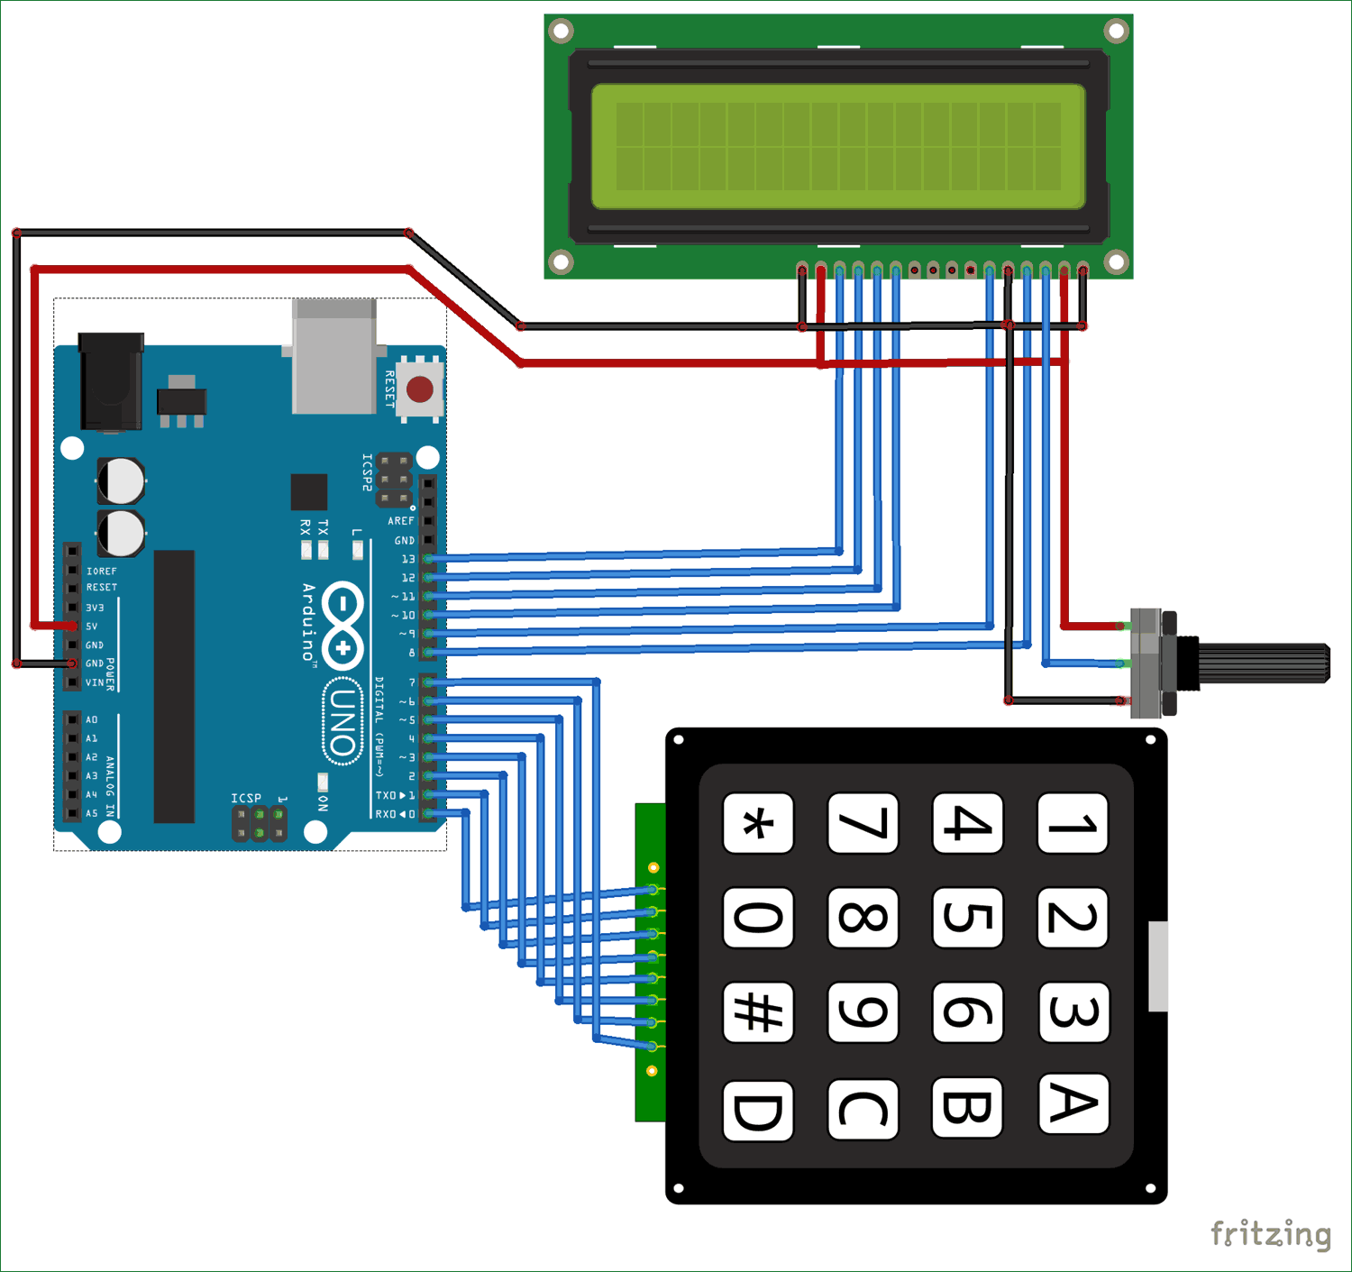

**Working:**

We are required to interface a keypad with Arduino UNO and LCD. A function in code has been added which has code for interfacing keypad as well as LCD crystal display. Both of these codes and snippet and libraries have been uploaded on github.

We are talking an input string from serial monitor converting this Serial byte stream into string.

For e.g. if equation is 23+34

Code converts first chunk of string till operator to float (Note. We are talking float to use decimal values as well for calculation purposes) and the later part to float. We are running an if statement with switch case if an operator is detected according to that operator perform a specific task. This code file has been uploaded in same folder as this file.

**IMPORTANT STEPS:**

**First of all interface keypad and make sure its working**

**Now interface LCD carefully**

**Before running the entire lcd code make sure to run an example code of LCD in Arduino Examples.**

**Now write code for conversion of serial input to string and upload on Arduino.**

**Make sure serial monitor Baud Rate is set to same as in code.**